|  |  |  |
| --- | --- | --- |
| **Augmentation** | **Description** | **Accuracy** |
| Default | Original Image | 88.06% |
| Upscale | Resizes image to 120% of original size | 86.57% |
| Downscale | Resized image to 80% of original size | 85.29% |
| Darken | Reduce brightness by 50% | 82.09% |
| Lighten | Increase brightness by 50% | 83.58% |
| Contrast up | Increase contrast by 50% | 82.09% |
| Contrast down | Decrease contrast by 30% | 85.29% |
| Rotate clockwise | Rotate image 15% clockwise | 77.61% |
| Rotate counter | Rotate image 15% counter-clockwise | 65.15% |
| Sharpen | Increase sharpness of image | 85.07% |
| Blur | Decreases the sharpness of the image | 85.29% |
| Desaturate | Reduces the color intensity of image | 85.29% |
| Saturate | Boosts color intensity of the image | 86.76% |
| Multiple | Includes brightness, contrast, resize, and sharpness of image | 76.12% |

**Augmentation None:**

Total images: 67

Correct predictions: 59

Accuracy: 88.06%

**Augmentation upscale:**

Total images: 67

Correct predictions: 58

Accuracy: 86.57%

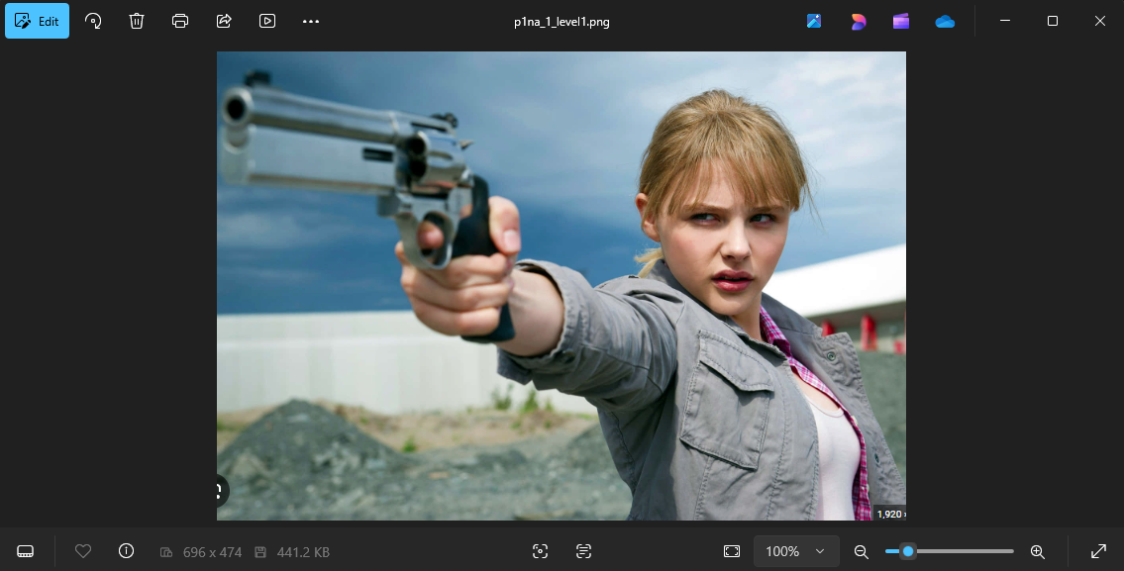

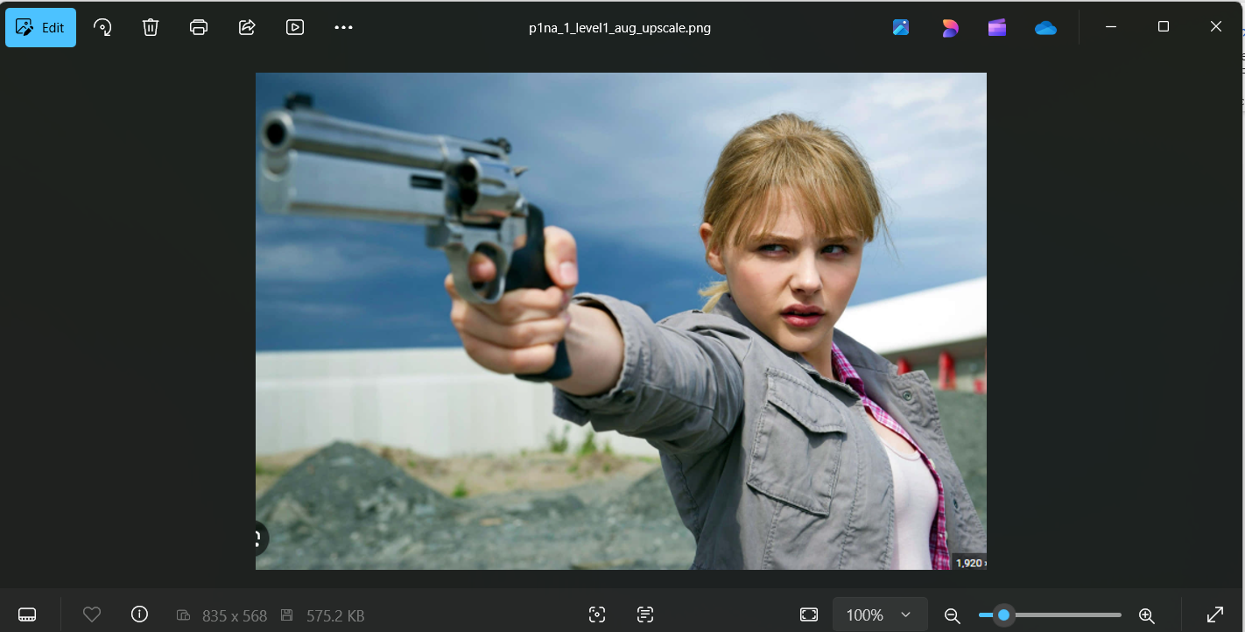

**Augmentation downscale:**

Total images: 68

Correct predictions: 58

Accuracy: 85.29%

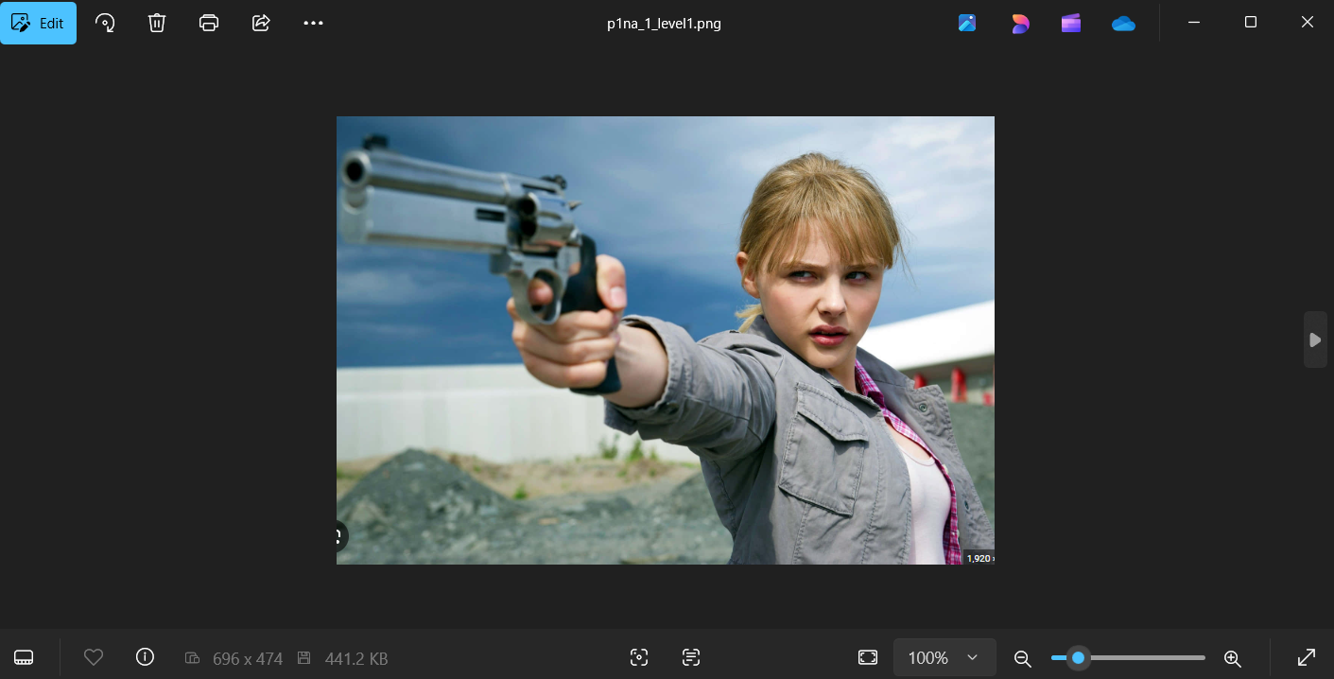

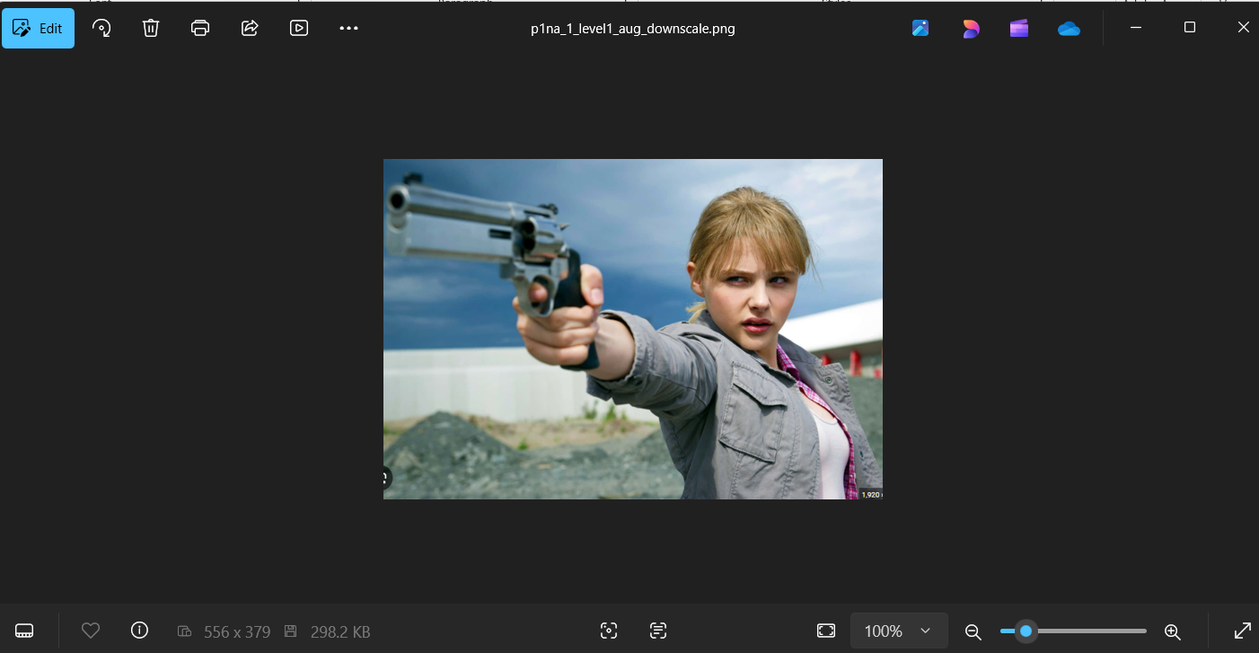

**Augmentation darken:**

Total images: 67

Correct predictions: 55

Accuracy: 82.09%



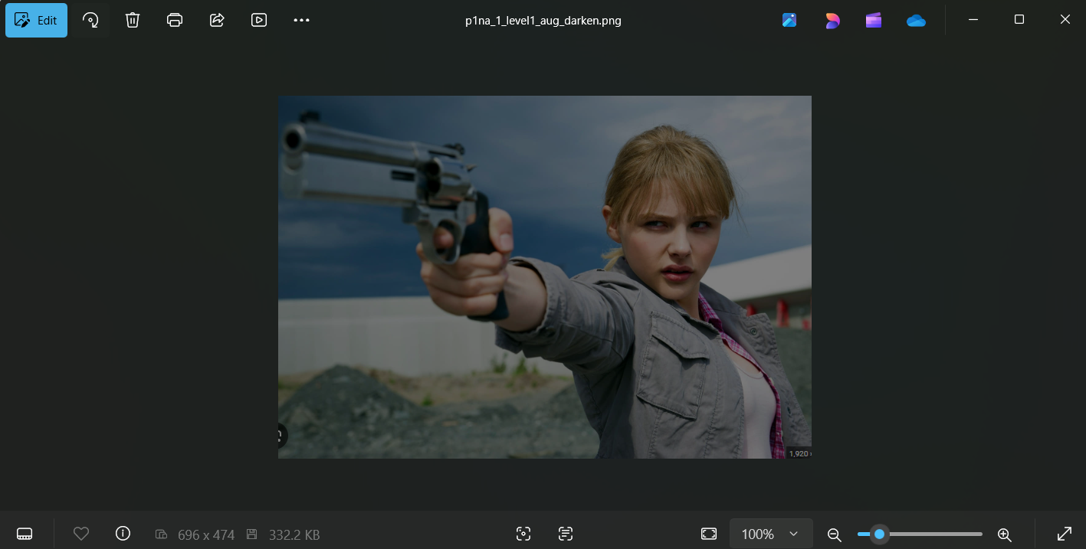

**Augmentation lighten:**

Total images: 67

Correct predictions: 56

Accuracy: 83.58%

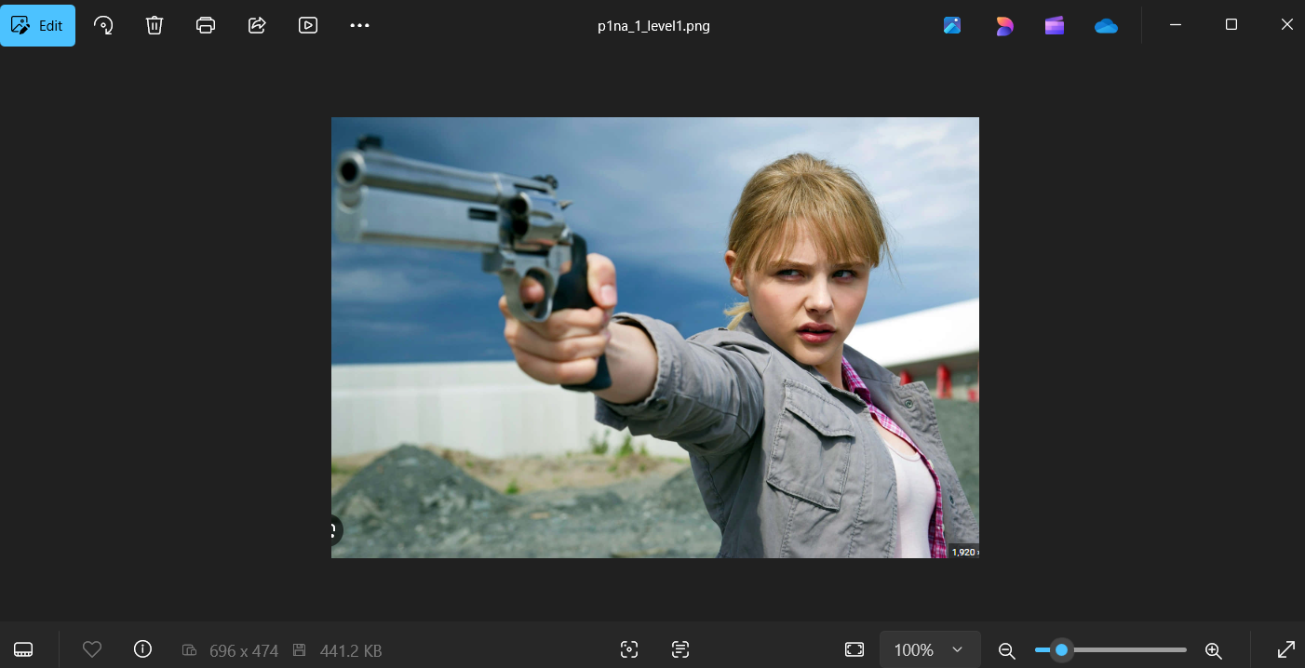

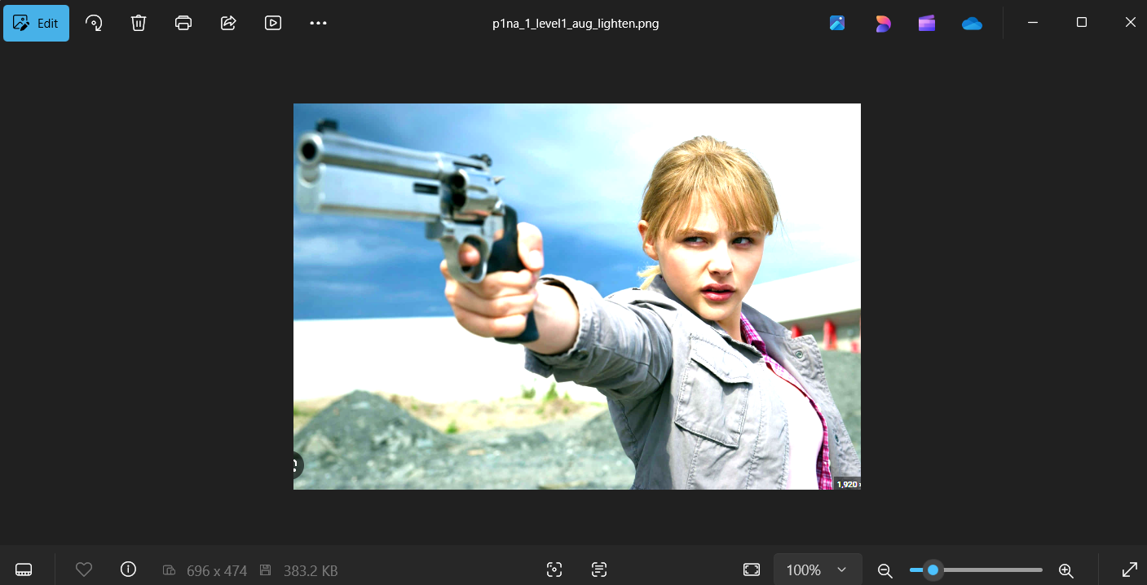

**Augmentation contrast_up:**

Total images: 67

Correct predictions: 55

Accuracy: 82.09%

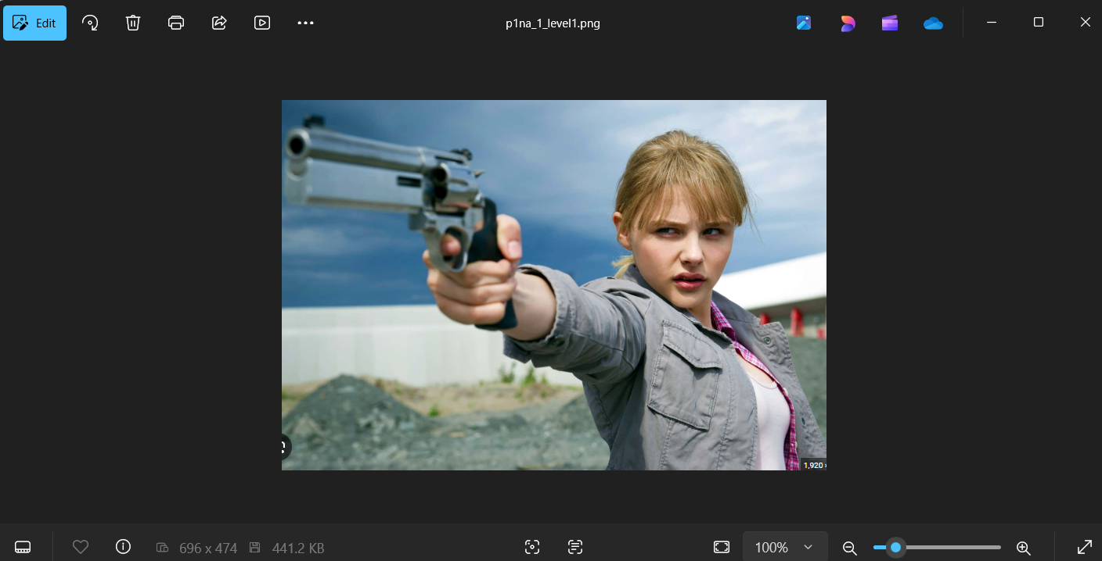

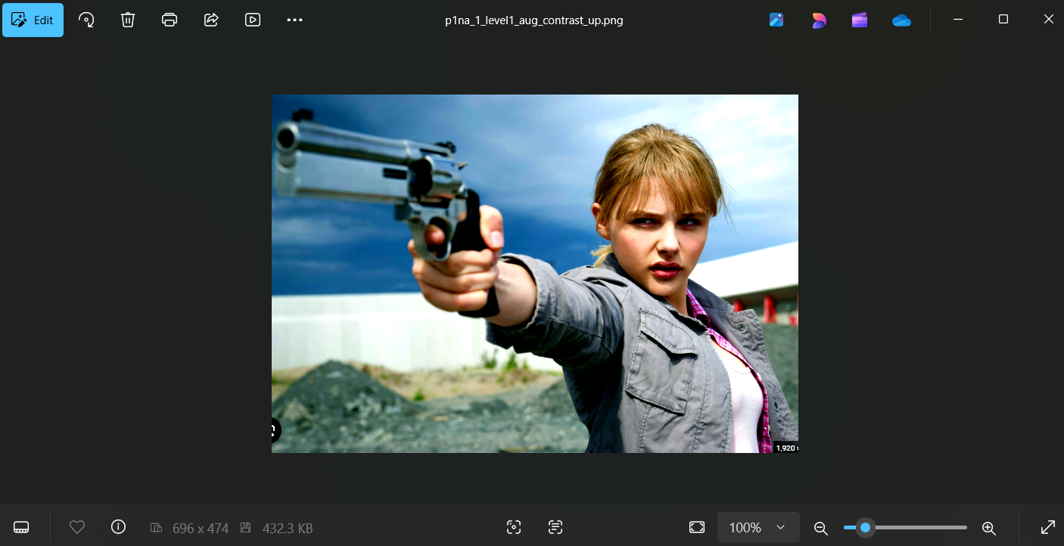

**Augmentation contrast_down:**

Total images: 68

Correct predictions: 58

Accuracy: 85.29%



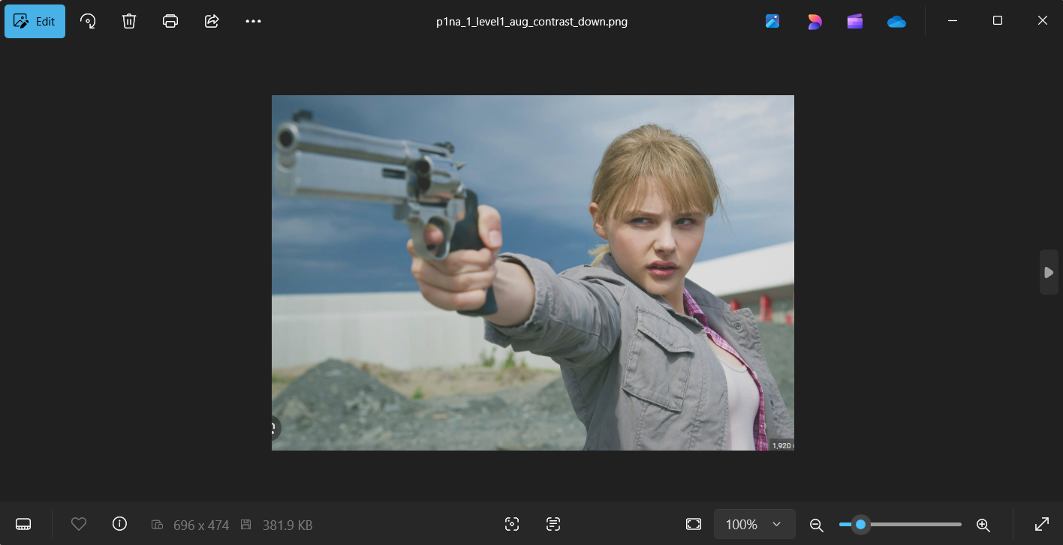

**Augmentation rotate15:**

Total images: 67

Correct predictions: 52

Accuracy: 77.61%



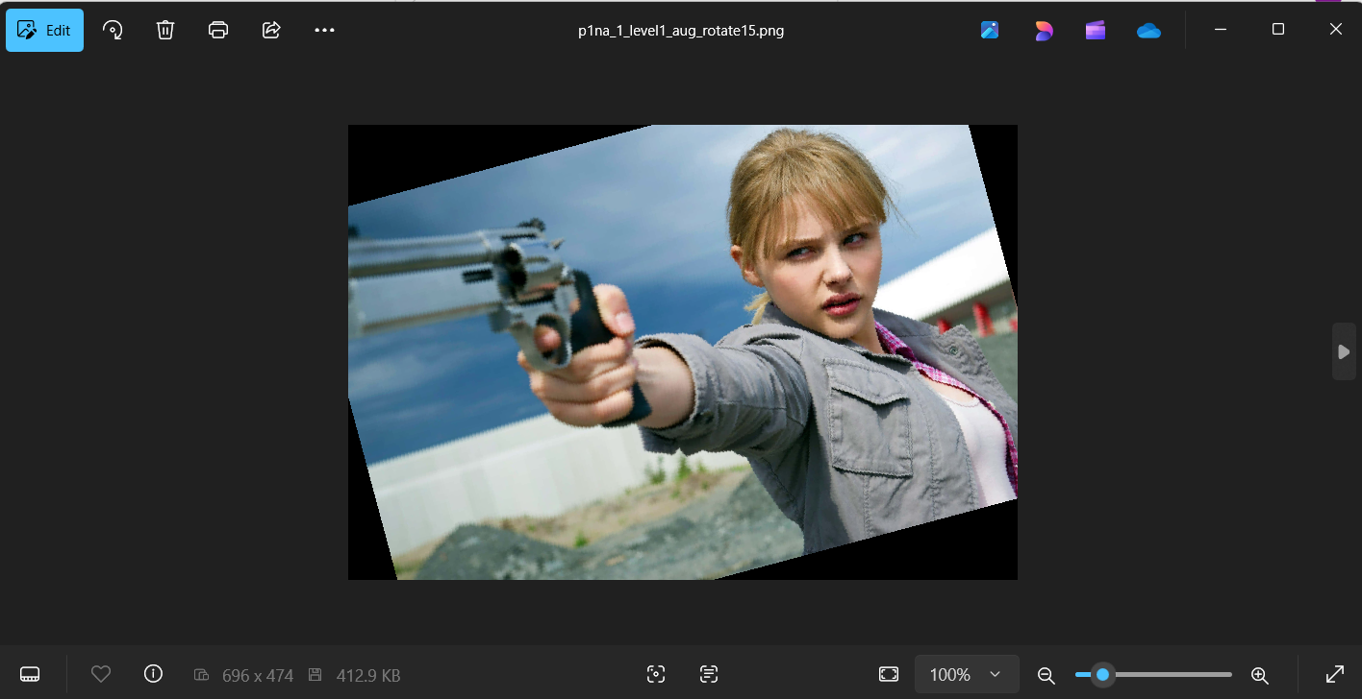

**Augmentation rotate-15:**

Total images: 66

Correct predictions: 43

Accuracy: 65.15%



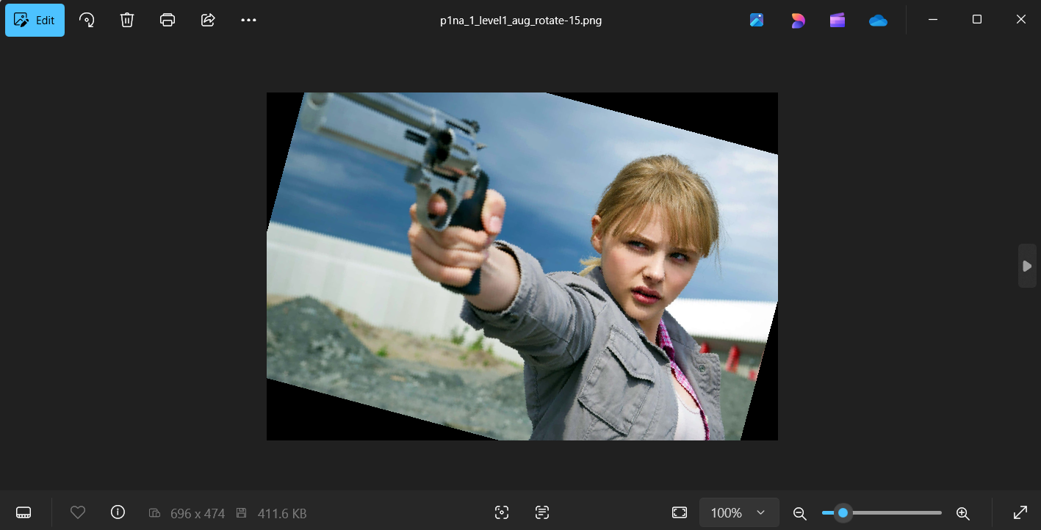

**Augmentation sharpen:**

Total images: 67

Correct predictions: 57

Accuracy: 85.07%



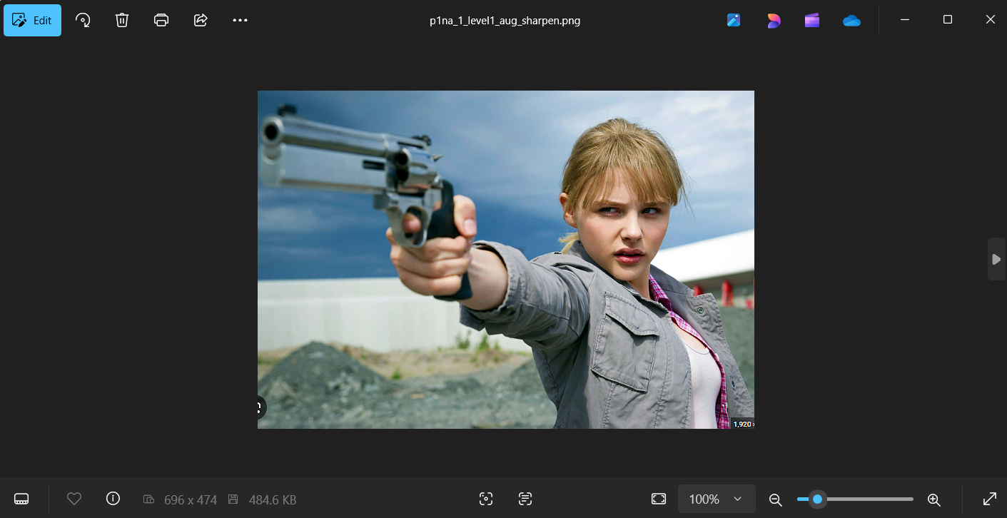

**Augmentation blur:**

Total images: 68

Correct predictions: 58

Accuracy: 85.29%



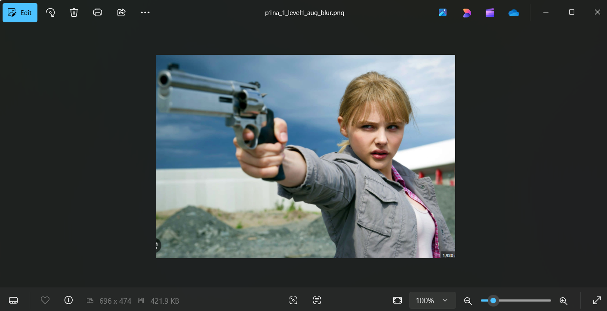

**Augmentation desaturate:**

Total images: 68

Correct predictions: 58

Accuracy: 85.29%



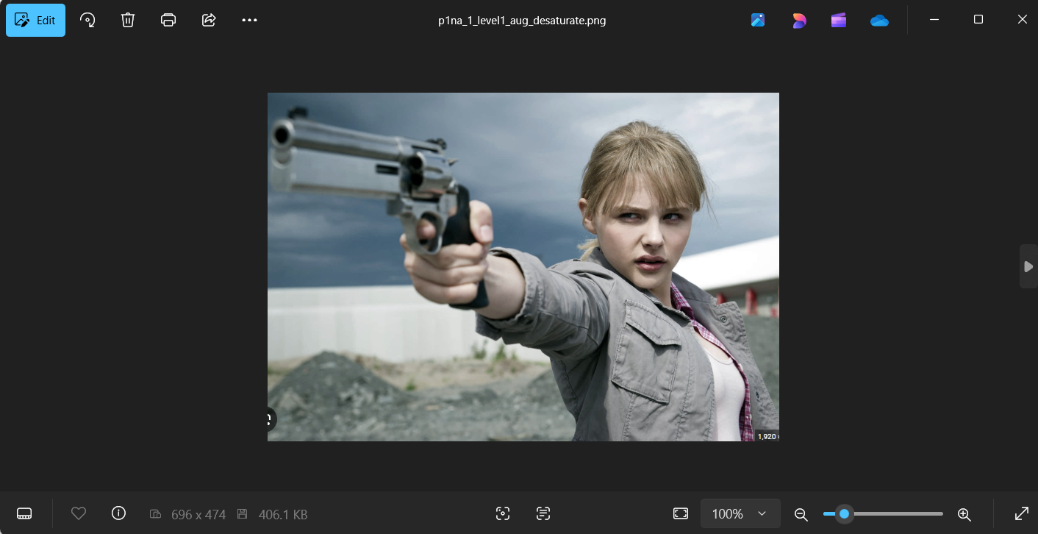

**Augmentation saturate:**

Total images: 68

Correct predictions: 59

Accuracy: 86.76%



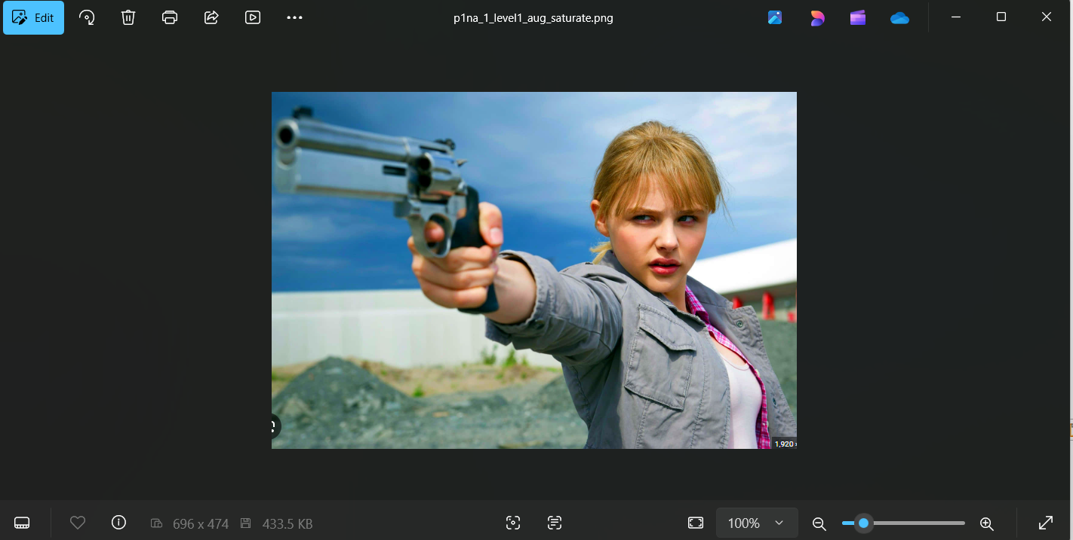

**Augmentation multiple:**

Total images: 67

Correct predictions: 51

Accuracy: 76.12%



